officedown example

{officedown} example

A two columns section

Lorem ipsum dolor sit amet, consectetur adipiscing elit. Nulla eu pulvinar arcu, quis aliquam dui.
In at cursus ante.
Curabitur ligula quam, iaculis faucibus orci quis, vestibulum lobortis lectus.
Suspendisse fringilla nisl pulvinar, laoreet tellus sed.

Tables
head(mtcars)
Table : caption 1
mpg | cyl | disp | hp | drat | wt | qsec | vs | am | gear | carb
21.0 | 6 | 160 | 110 | 3.90 | 2.620 | 16.46 | 0 | 1 | 4 | 4
21.0 | 6 | 160 | 110 | 3.90 | 2.875 | 17.02 | 0 | 1 | 4 | 4
22.8 | 4 | 108 | 93 | 3.85 | 2.320 | 18.61 | 1 | 1 | 4 | 1
21.4 | 6 | 258 | 110 | 3.08 | 3.215 | 19.44 | 1 | 0 | 3 | 1
18.7 | 8 | 360 | 175 | 3.15 | 3.440 | 17.02 | 0 | 0 | 3 | 2
18.1 | 6 | 225 | 105 | 2.76 | 3.460 | 20.22 | 1 | 0 | 3 | 1

Reference
see figure and table !

figures

A boxplot
boxplot(1:8)
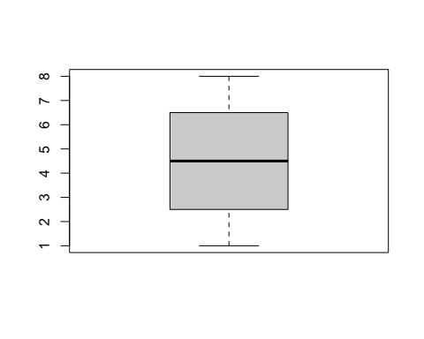
Figure : A boxplot

Landscape section
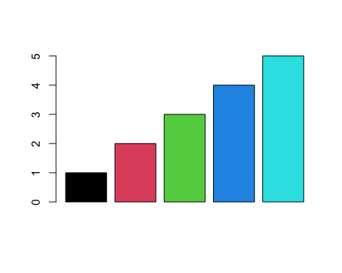

Table of Contents

Table of figures

Table of tables

