Table of content
block_toc()

Table of figures
block_toc(style = "Image Caption")

{officedown} example

Tables
head(faithfuld)
Table : caption 1
eruptions | waiting | density
1.600000 | 43 | 0.003216159
1.647297 | 43 | 0.003835375
1.694595 | 43 | 0.004435548
1.741892 | 43 | 0.004977614
1.789189 | 43 | 0.005424238
1.836486 | 43 | 0.005744544

figures
ggplot(faithfuld, aes(waiting, eruptions)) +
geom_raster(aes(fill = density))
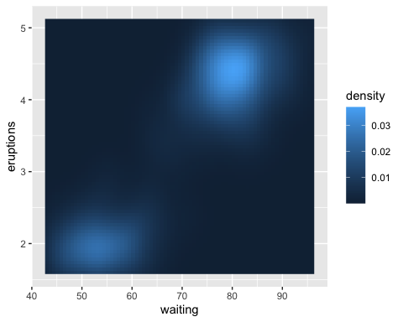
Figure : A boxplot

