Figure
ggplot(economics, aes(date, unemploy / pop)) +
geom_line() +
theme_minimal()
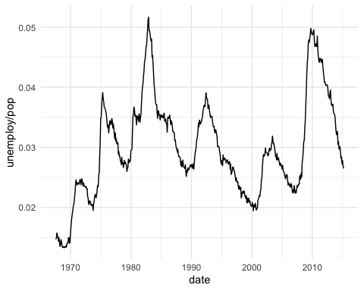
Figure : economics plot

Table
head(economics)
Table : economics table
date | pce | pop | psavert | uempmed | unemploy
1967-07-01 | 506.7 | 198712 | 12.6 | 4.5 | 2944
1967-08-01 | 509.8 | 198911 | 12.6 | 4.7 | 2945
1967-09-01 | 515.6 | 199113 | 11.9 | 4.6 | 2958
1967-10-01 | 512.2 | 199311 | 12.9 | 4.9 | 3143
1967-11-01 | 517.4 | 199498 | 12.8 | 4.7 | 3066
1967-12-01 | 525.1 | 199657 | 11.8 | 4.8 | 3018

