Figure
ggplot(economics, aes(date, unemploy / pop)) +
geom_line() +
theme_minimal()
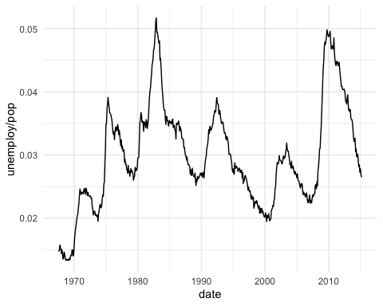
Figure : economics plot

Tables

economics
head(economics)
Table : economics table
date | pce | pop | psavert | uempmed | unemploy
1967-07-01 | 506.7 | 198712 | 12.6 | 4.5 | 2944
1967-08-01 | 509.8 | 198911 | 12.6 | 4.7 | 2945
1967-09-01 | 515.6 | 199113 | 11.9 | 4.6 | 2958
1967-10-01 | 512.2 | 199311 | 12.9 | 4.9 | 3143
1967-11-01 | 517.4 | 199498 | 12.8 | 4.7 | 3066
1967-12-01 | 525.1 | 199657 | 11.8 | 4.8 | 3018

mtcars
head(mtcars)
Table : mtcars table
mpg | cyl | disp | hp | drat | wt | qsec | vs | am | gear | carb
21.0 | 6 | 160 | 110 | 3.90 | 2.620 | 16.46 | 0 | 1 | 4 | 4
21.0 | 6 | 160 | 110 | 3.90 | 2.875 | 17.02 | 0 | 1 | 4 | 4
22.8 | 4 | 108 | 93 | 3.85 | 2.320 | 18.61 | 1 | 1 | 4 | 1
21.4 | 6 | 258 | 110 | 3.08 | 3.215 | 19.44 | 1 | 0 | 3 | 1
18.7 | 8 | 360 | 175 | 3.15 | 3.440 | 17.02 | 0 | 0 | 3 | 2
18.1 | 6 | 225 | 105 | 2.76 | 3.460 | 20.22 | 1 | 0 | 3 | 1

Cross-referencing
Figure and table have auto-numbered captions that can be cross referenced:
- This is a linked reference to a figure , its number is computed by Word and it’s linked to the corresponding graphic when clicking on it.
- This is a linked reference to a table , its number is computed by Word and it’s linked to the corresponding table when clicking on it. This is a linked reference to a table .

