Blah blah blah blah blah blah blah blah blah blah blah blah blah blah blah blah blah blah blah blah blah blah blah blah blah blah blah blah blah blah blah blah blah blah blah blah blah blah blah blah blah blah blah blah blah blah blah blah blah blah blah blah blah blah blah blah blah blah blah blah blah blah blah blah blah blah blah blah blah blah blah blah blah blah blah blah blah blah blah blah blah blah blah blah blah blah blah blah blah blah blah blah blah blah blah blah blah blah blah blah.
Figure : Faithfuld plot
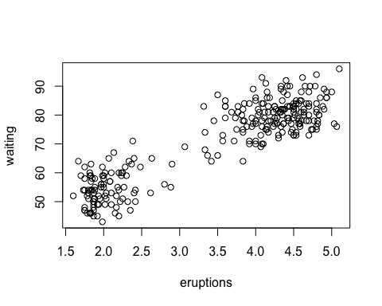
Blah blah blah blah blah blah blah blah blah blah blah blah blah blah blah blah blah blah blah blah blah blah blah blah blah blah blah blah blah blah blah blah blah blah blah blah blah blah blah blah blah blah blah blah blah blah blah blah blah blah blah blah blah blah blah blah blah blah blah blah blah blah blah blah blah blah blah blah blah blah blah blah blah blah blah blah blah blah blah blah blah blah blah blah blah blah blah blah blah blah blah blah blah blah blah blah blah blah blah blah.
This is a reference to .
Blah blah blah blah blah blah blah blah blah blah blah blah blah blah blah blah blah blah blah blah blah blah blah blah blah blah blah blah blah blah blah blah blah blah blah blah blah blah blah blah blah blah blah blah blah blah blah blah blah blah blah blah blah blah blah blah blah blah blah blah blah blah blah blah blah blah blah blah blah blah blah blah blah blah blah blah blah blah blah blah blah blah blah blah blah blah blah blah blah blah blah blah blah blah blah blah blah blah blah blah.

